Concur Invoice Workflow

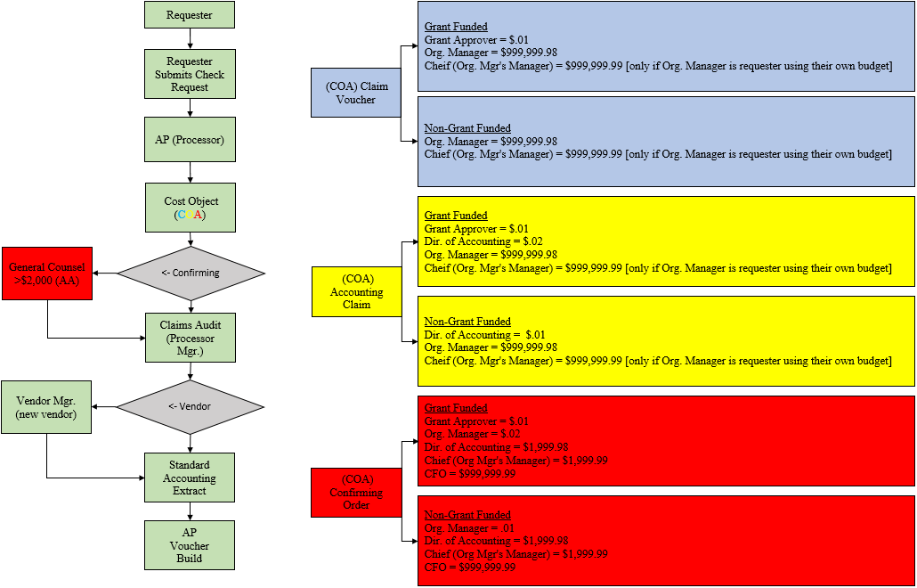

Requesting direct payments – Check Requests

1. Requester check request step
   * Requester selects vendor and vendor remit address.
     + If vendor is not available – Request New Vendor is selected, all required fields are filled in, and W-9/invoice is uploaded.
   * Requester enters Request Name, Invoice Number, Invoice Date, Remittance Message, Total Invoice Amount, Comments/Confirming Explanation, selects Mail Attachments with Check if needed, and selects Emergency Check Run if needed.
   * Requester uploads supporting documentation.
   * Requester selects budget string Account (Commodity), Fund, Organization, Program, Subclass, and Project (Grants Only).
     + Workflows are based on Account (Commodity).
       1. Confirming Order
       2. Claim Voucher
       3. Accounting
   * Requester submits payment request.
2. Accounts Payable approval step
   * New vendor claims
     + AP provides vendor info to Purchasing (print/email).
     + Purchasing responds with the vendor ID when the setup is complete.
   * AP verifies information, corrects if possible, and/or sends the claim back to requester for correction.
     + Account (Commodity)
     + Vendor
     + Remit Address
     + Invoice number
     + Invoice date
     + Amount
   * If the request is a funded by a Trust, AP rep must forward to Sally Combs.
   * If approved the request is routed forward. If rejected the request is sent back to the employee with explanation.
3. Cost Object Approval (COA)
   * Workflows are based on Account (Commodity).
     + Confirming Order = Confirming account commodity.
       1. Grant Approver (if E, F, or G fund)
       2. Org. Manager
       3. Director of Accounting
       4. Org. Manager’s Supervisor (if > $2,000, or Org. Manager is the Requester)
       5. Chief Financial Officer (if > $2,000)
     + Claim Voucher = Allowable account commodity
       1. Grant Approver (if E, F, or G fund)
       2. Org. Manager
       3. Org. Manager’s Supervisor (if Org. Manager is the Requester)
     + Accounting = Non-expense account commodity
       1. Grant Approver (if E, F, or G fund)
       2. Director of Accounting
       3. Org. Manager
       4. Org. Manager’s Supervisor (if Org. Manager is the Requester)
   * Org. Code on the budget code connected list determines manager.
   * If approved the request is routed forward. If rejected the request is sent back to the employee with explanation.
4. General Counsel approval step
   * If the account is a Confirming Order commodity and is >$2000 it is routed to the General Council.
   * If the request is approved it is routed forward. If denied the request is routed back to employee with explanation.
5. Claims Audit approval step
   * If report is approved, the report is routed forward. If denied the report is routed back to employee with explanation.

Automated process

1. Payment Request Accounting Extract (PRAE) is generated
2. SAE upload into PeopleSoft and Vouchers are built

|  |  |  |
| --- | --- | --- |
| Account | | Workflow |
| 1480 | Prepaid Expenses | Accounting Claim Workflow |
| 1575 | Due From RJSCB | Accounting Claim Workflow |
| 2180 | Due To Other Governments | Accounting Claim Workflow |
| 2300 | Accrued Liabilities | Accounting Claim Workflow |
| 2992 | Suspense-Advance Deposits | Accounting Claim Workflow |
| 4435 | Refunds Prior Year | Accounting Claim Workflow |
| 4455 | Student Fees-Miscellaneous | Accounting Claim Workflow |
| 5244 | Legal Services | Claim Voucher Workflow |
| 5414 | Pupil Accidents | Claim Voucher Workflow |
| 5415 | Independent Evaluations | Claim Voucher Workflow |
| 5424 | Travel In District | Claim Voucher Workflow |
| 5425 | Travel Out Of District | Claim Voucher Workflow |
| 5426 | Membership Fees (for employees) | Claim Voucher Workflow |
| 5428 | Travel Out Of District-Asar | Claim Voucher Workflow |
| 5432 | Testifying Fees | Claim Voucher Workflow |
| 5433 | Professional Development | Claim Voucher Workflow |
| 5439 | Admissions/Tournament Fees | Claim Voucher Workflow |
| 5462 | Postage | Claim Voucher Workflow |
| 5471 | Tuition-In State | Claim Voucher Workflow |
| 5472 | Tuition-Out Of State | Claim Voucher Workflow |
| 5473 | Health Serv-Othr Dist | Claim Voucher Workflow |
| 5474 | Tuition - Charter Schools | Claim Voucher Workflow |
| 5476 | Tuition-Dual Enrollment | Claim Voucher Workflow |
| 5481 | Scholarships | Claim Voucher Workflow |
| 5482 | Permits & Fees | Claim Voucher Workflow |
| 5486 | Sports Officials | Claim Voucher Workflow |
| 5492 | Adjustment & Disallowance | Claim Voucher Workflow |
| 5493 | Judgments & Claims | Claim Voucher Workflow |
| 5535 | Tool Allowance | Claim Voucher Workflow |
| 5590 | BOCES | Claim Voucher Workflow |
| 5813 | State Teachers Retirement | Claim Voucher Workflow |
| 5816 | Life Insurance | Claim Voucher Workflow |
| 5819 | Health Insurance - Ret Empl | Claim Voucher Workflow |
| 5820 | Dental Insurance Civ Serv | Claim Voucher Workflow |
| 5822 | Unemployment Insurance | Claim Voucher Workflow |
| 5823 | Workers Compensation | Claim Voucher Workflow |
| 5824 | Employee Assistance Program | Claim Voucher Workflow |
| 5825 | Tuition Reimbursement | Claim Voucher Workflow |
| 5826 | Moving Cost | Claim Voucher Workflow |
| 5833 | Health Insurance FSA Fee | Claim Voucher Workflow |
| 5834 | Disability Insurance | Claim Voucher Workflow |
| 5835 | Attendance Incentive | Claim Voucher Workflow |
| 5838 | Stop Loss and Admin Fees | Claim Voucher Workflow |
| 5916 | Interfd Xfer-Capital to RJSCB | Claim Voucher Workflow |
| 5200 | Equip-Other Than Buses | Confirming Order Workflow |
| 5210 | Equip-Buses | Confirming Order Workflow |
| 5220 | Computer Hardware | Confirming Order Workflow |
| 5240 | Contractual Expense | Confirming Order Workflow |
| 5245 | Architect's Fees | Confirming Order Workflow |
| 5246 | Survey & Engineering Fees | Confirming Order Workflow |
| 5293 | General Construction | Confirming Order Workflow |
| 5294 | Heating & Ventilation | Confirming Order Workflow |
| 5295 | Plumbing | Confirming Order Workflow |
| 5296 | Electrical | Confirming Order Workflow |
| 5297 | Site Improvement | Confirming Order Workflow |
| 5380 | Library Books | Confirming Order Workflow |
| 5381 | Textbooks K-6 | Confirming Order Workflow |
| 5382 | Textbooks 7-12 | Confirming Order Workflow |
| 5387 | Library Books Non-CSD | Confirming Order Workflow |
| 5411 | Liability & Fire Insurance | Confirming Order Workflow |
| 5413 | Physicals-Standard | Confirming Order Workflow |
| 5417 | Radio Repair | Confirming Order Workflow |
| 5418 | Suspension & Spring Repair | Confirming Order Workflow |
| 5419 | Glass Repair | Confirming Order Workflow |
| 5420 | Radiator & Heater Repair | Confirming Order Workflow |
| 5421 | Rental Of Land & Bldgs | Confirming Order Workflow |
| 5422 | Rental Of Equipment | Confirming Order Workflow |
| 5423 | Rental-Parking Lots | Confirming Order Workflow |
| 5427 | Meals | Confirming Order Workflow |
| 5429 | Fingerprinting | Confirming Order Workflow |
| 5430 | Prof & Tech Services | Confirming Order Workflow |
| 5431 | Professional & Tech Services | Confirming Order Workflow |
| 5434 | Contract Gasoline | Confirming Order Workflow |
| 5435 | Transport-Contracts | Confirming Order Workflow |
| 5436 | Transport-Passes-Public | Confirming Order Workflow |
| 5437 | Transport-Tokens-Public | Confirming Order Workflow |
| 5438 | Transport-Field Trips | Confirming Order Workflow |
| 5441 | Utilities-Gas Contract | Confirming Order Workflow |
| 5443 | Utilities-Electric | Confirming Order Workflow |
| 5444 | Utilities-City Water | Confirming Order Workflow |
| 5445 | Utilities-Telephone | Confirming Order Workflow |
| 5446 | Utilities-Data Lines | Confirming Order Workflow |
| 5448 | Utilities-Pure Water Tax | Confirming Order Workflow |
| 5449 | Environmental Service | Confirming Order Workflow |
| 5450 | Cartage Or Freight | Confirming Order Workflow |
| 5451 | Laundry & Cleaning | Confirming Order Workflow |
| 5452 | Serv Conts & Equip Repair | Confirming Order Workflow |
| 5453 | Front End Alignments | Confirming Order Workflow |
| 5454 | Gen Construction Contract | Confirming Order Workflow |
| 5455 | Heat & Vent Contracts | Confirming Order Workflow |
| 5456 | Plumbing Contracts | Confirming Order Workflow |
| 5457 | Electrical Contracts | Confirming Order Workflow |
| 5459 | Building Furnishings | Confirming Order Workflow |
| 5460 | Snow Plowing | Confirming Order Workflow |
| 5461 | Printing & Advertising | Confirming Order Workflow |
| 5464 | Recruitment-Personnel | Confirming Order Workflow |
| 5466 | Driver License-Testing | Confirming Order Workflow |
| 5468 | Awards | Confirming Order Workflow |
| 5470 | Tire Repair | Confirming Order Workflow |
| 5477 | Food Svc Management Fee | Confirming Order Workflow |
| 5478 | Food Svc Direct Expense | Confirming Order Workflow |
| 5489 | Testing Materials & Fees | Confirming Order Workflow |
| 5499 | Departmental Credits | Confirming Order Workflow |
| 5500 | Instructional Supplies | Confirming Order Workflow |
| 5505 | Prof Books & Publications | Confirming Order Workflow |
| 5511 | Office Supplies | Confirming Order Workflow |
| 5520 | Supplies - Computer Hardware | Confirming Order Workflow |
| 5521 | Food for Resale & Provisions | Confirming Order Workflow |
| 5522 | Lunchroom Supplies | Confirming Order Workflow |
| 5531 | Custodial Supplies | Confirming Order Workflow |
| 5532 | Shop Supplies | Confirming Order Workflow |
| 5533 | Maintenance & Repair Supplies | Confirming Order Workflow |
| 5534 | Uniforms | Confirming Order Workflow |
| 5542 | Duplicating & Copying | Confirming Order Workflow |
| 5551 | Medical Supplies | Confirming Order Workflow |
| 5560 | Computer Software | Confirming Order Workflow |
| 5561 | Auto Parts | Confirming Order Workflow |
| 5562 | Gasoline | Confirming Order Workflow |
| 5564 | Tires & Tubes | Confirming Order Workflow |
| 5566 | Oil | Confirming Order Workflow |
| 5580 | Storehouse Inventory Purchase | Confirming Order Workflow |
| 5615 | Install Purch Debt-Other Prin | Confirming Order Workflow |
| 5616 | Capital Leases - Principal | Confirming Order Workflow |
| 5715 | Install Purch Debt-Othr Intr | Confirming Order Workflow |
| 5716 | Capital Leases - Interest | Confirming Order Workflow |
|  |  |  |